BILL OF MATERIALS
Product: HEB 4 LB POUCH
Pouch Specifications:
- Pouch is blue with red and green
- Dimensions of pouch are: 8.5” W X 11”T
- Pouch fitted with gusseted bottom and zipper top
Pouch Machine Recipe:
- Select program titled (4LB) on Leepack machine
- Use program # 4 on the scales
- Set speed at 30 per minute
Case Specification:
- Case is brown corrugated with black print
- Case inside dimensions are: 11- 1/16”W x 5-5/8”D x 16 – 5/8”L
Packing Specification:
- 6 ct. pouches / case , packed horizontally into case
- Date code to be applied both to pouch and case
- Date code for case must have the date code followed by HEB to be printed on outside of case
- The four digit date code represents the date of packaging (i.e. 02-09-2009 = 0409 which means the 40th day of the year 2009
- The { EXP } means expiration which is three years ( i.e. EXP 0212 ) The 0212 means the second month of the year 2009
- Date code on outside of box will be two lines the top will be the date code the bottom will be (HEB)
- 63 cases/pallet corner boards on each corner double stretch wrapped with outside pouch indicator. Every other pallet to have top slip sheet.
- Numeric order of production (i.e.1,2,3,4) and date of manufacture to be written outside stretch wrap
- Do NOT double stack in warehouse
Pallet Configuration:
- 9 cases per layer, column stacked 7 high=63 cases per pallet 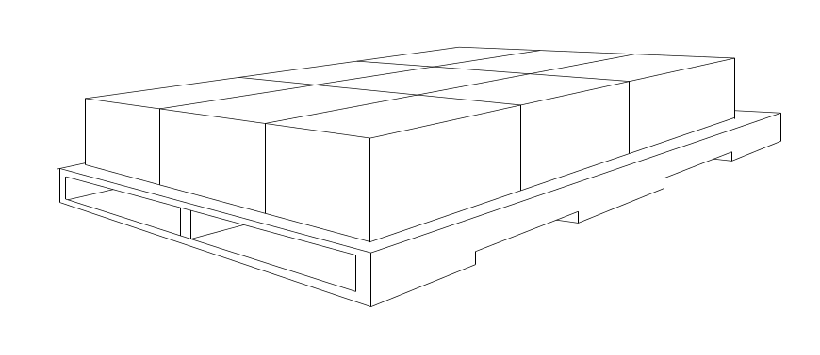

Rev: 00
Date: 03/30/2011

